

Mentoring, Training & Placements Department
Daily Report 24-03-2026
Description |  | Total to be received | Received till Date | Received Date | To be received

II | Staff Attendance
S.No | Dept. | Category | On Rolls | Absent | DQI | DQI Performance | Overall DQI | Overall Performance
1 | MTP |  | 8 | 0

 | III. Students’ Attendance:
IV | MTP:  SAMUEL  - Zensar on-campus drive - Mr. Kishore, HR has addressed the students during pre-placement talk and organized the test process. 125 students from VNR & GRIET together are taking test.  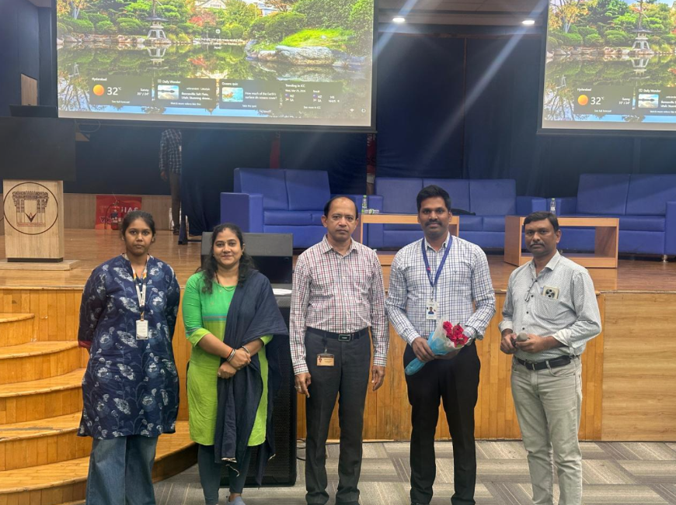  - JPMC - has shared the assessment instructions for Summer Internship hiring. Forwarded the details to 2028 batch (2nd years). Test will be active for 48 hours on 25th and 26th March.  - Invesco summer internship hiring for 2027 batch - shared a list of 51 students with HR for the upcoming hiring process. Selects will pursue internship during June-Aug 2026.  - DBS Apprentice hiring process for 2027 batch - Confirmed the hiring and requested for database of CSE, IT and AIML students. Working on the database  KABITA  - Ctrls: 11 students selected for Ctrls with package 5.25 LPA-5.5 LPA. Information shared with selected students.  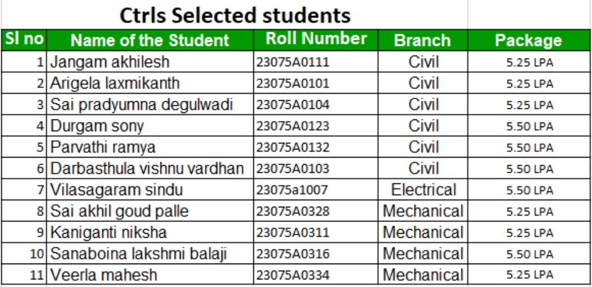  - FedEx: 3 students selected for FedEx Initial internship 3-6 month with stipend: 35k upon FTE package will be 10LPA.Information shared with students. In addition to previous 3 offers ,Total selects as of now 6 selects from FedEx.  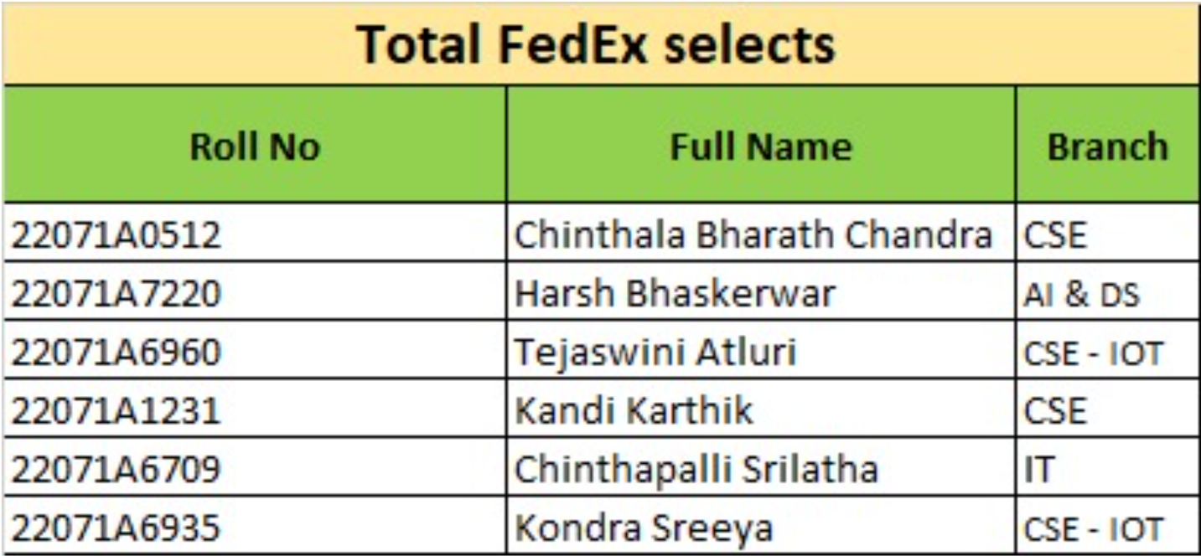  - NextGen: Opportunity for batch 2027 AIML students Stipend: 25 K CTC: 7 to 8 LPA. Registration & data collection in progress.  - DTCC From batch 2027, 14 students shortlisted for DTCC interview scheduled on 25th March @ DTCC office. Already detailed email shared with the students along with address details. TnP department is organized a mock interview session today, on 24th March -2026.  POONAM  - M/s. Cheriesh Building Systems Pvt Ltd Hiring for M.Tech Structural Engineering- 2025 & 2026 batch Location- Hyderabad CTC. 3 LPA. Communicated with students, yet to be receive students’ profiles.  - OKI–Summer Internship 2026: Language Digitization Program, Internship program for 45-day online shared with all the students 2026 batch with registration link  - Dr. K V M Achuta Ramaiah and Dr. K V Ramana conducted a training and orientation session at P-417 from 2 – 4 PM attended by 11 shortlisted students (2027batch) in view of the DTCC in view of their interviews scheduled tomorrow at DTCC office.  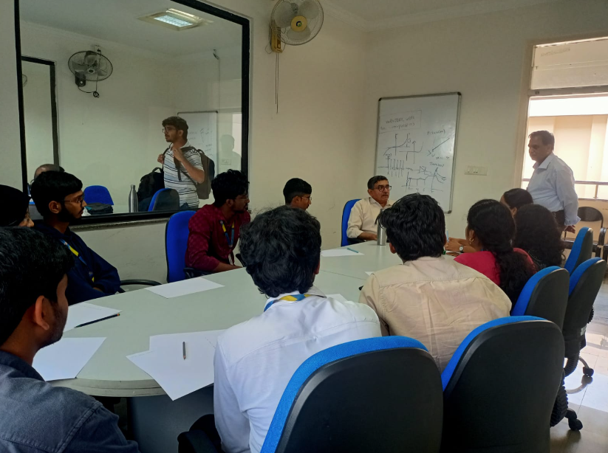 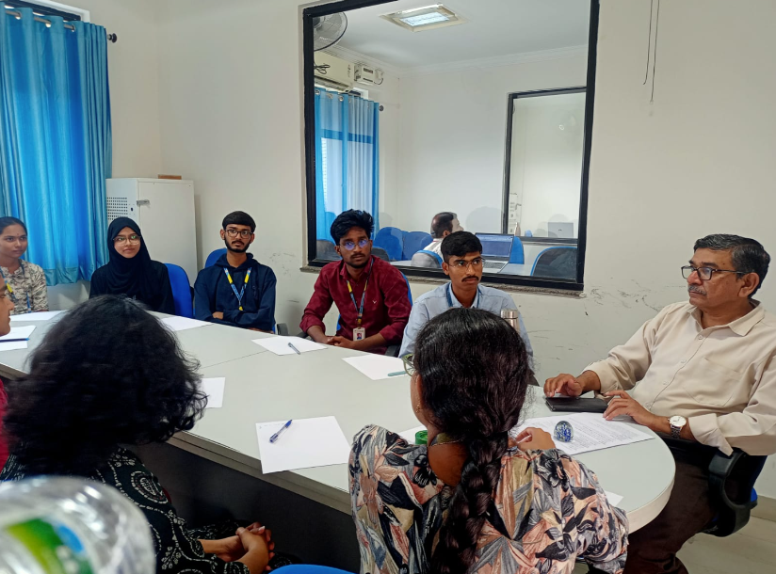 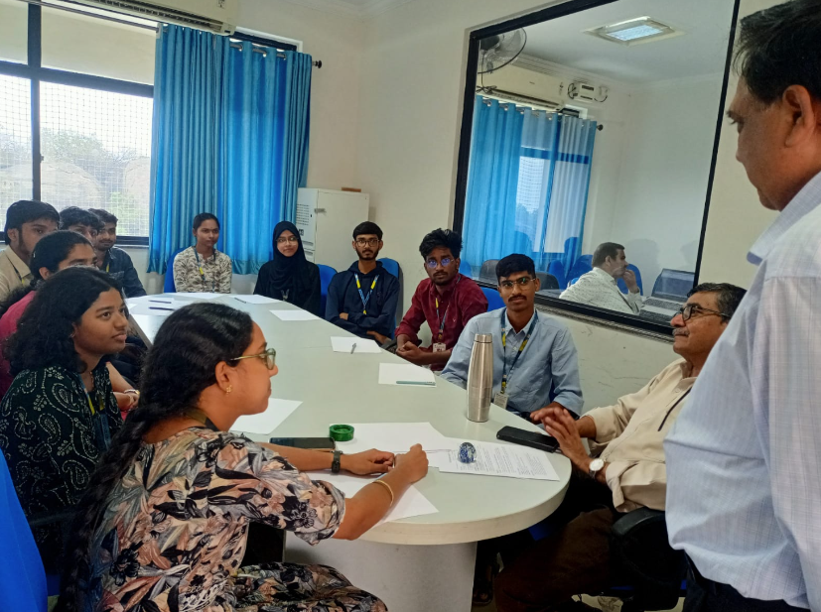  - The Training & Placements Department is organized a Technical Training Session on Advanced Data Structures on 23rd March 2026 from 7:00 PM to 9:00 PM. The session will be conducted in online mode for B.Tech 3rd Year 2nd Semester students of CSE, IT and Allied branches.  - This program was organized in view of the upcoming Infosys-HackWithInfy Assessment scheduled on 28th March 2026, to help students strengthen their problem-solving skills and technical knowledge.  - The training covered key topics including Binary Search Trees (BST), Graphs, and Dynamic Programming.  - The meeting link for the session was shared at 6:00 PM yesterday. All eligible students attended the session.  V HOD-CSE (CSDS&AIDS):  VI HOD-IT:  VII HOD-ECE:  2025 2026 Batch Plis open Summary:  CSE CSBS AIML IOT DS CyS AIDS IT ECE EEE EIE ME CE AE M.TECH TOTAL  354 64 276 83 182 62 63 244 205 76 91 50 49 17 12 1828  2025
VIII Classwork Adjustment / Lectures Interchanged:
S. No. | Dept | Subject | Adjusted from | Adjusted to

IX. Participation by Staff/Students:
S.No | Name | Event | Status (delegate /paper)resent, speaker) | Date and  Duration

X | Particulars of Library Services or Transactions: | No.s

For Head of the Department.

